**What is an Objective?**

An **objective** is a narrowly defined goal for a project that leads to a specific, measurable change. A project can have multiple objectives, but having more objectives is *not* always better. ***Objectives should focus on the most important changes that the project will lead to.***

When setting **project objectives**, it is important to consider what problem your project seeks to address and what specific changes you can make to resolve it by the end of your project. Your project objectives are distinct from the ISOC Foundation’s **program objectives**, which are addressed below.

**What are Indicators?**

An **Indicator** is the specific data that is used to measure progress made towards accomplishing an objective. All strong objectives should have at least one indicator, and some can have multiple indicators. You must be able to measure all your indicators **by collecting data that is reliable. This can be data directly collected by yourself (e.g., survey, interview) or data collected by a third party (e.g. administrative data, geospatial data).** A **target** refers to the desired measurement of the indicator at the **end** of the project. Ideally, you should have a sense of the existing measurement of the indicator before the beginning of the project (or, in other words, at **baseline**).

When setting indicators for each objective, you must consider what data is most important and relevant to measuring the change over time you wish to see.

**What are the benefits of strong objectives in a grant application?**

Well-written objectives make grant proposals very clear and easy for grantmaking organizations (or funders) to evaluate. Most grantmaking organizations want to see the specific and measurable results and impacts of the projects they fund. Strong objectives make these things obvious. Projects with clear objectives:

* Are easier to understand
* Are more likely to receive funding
* Reduce the number of additional questions funders may have about the application
* Can be used to clearly demonstrate an organization’s achievements and impact on their communities
* Can increase an organization’s ability to secure additional or future funding from various funders

**How do I write strong objectives?**

A well-written objective is SMART: **S**pecific, **M**easurable, **A**chievable, **R**elevant, and **T**ime-Bound. While, there is no one correct way to write objectives, a SMART objective clearly includes the following elements:

S: Specific; the objective states exactly what your project will accomplish

M: Measurable; the objective uses data to demonstrates that the outcome was accomplished

A: Achievable; the objective is realistic with the proposed resources (budget/staff/partnerships) and sets a clear target outcome for the project

R: Relevant; the project objective is clearly related to the project’s broader goal and the problem that it proposes to solve

T: Time-Bound; the objective’s proposed outcome will be achieved within the duration of the grant period

This will look different for every project. Below are a few examples of strong and weak objectives for a fictional proposed project.

|  |  |
| --- | --- |
| **Sample Project Objectives** | **Analysis** |
| By the end of the project period, two secondary schools in the town of Isocville will be connected to the internet by installing two new connectivity points to the local community network. | This is a **strong** objective. It states the timeline (the project period), the specific outcome (secondary schools connected to the internet), and sets an achievable target change (2 schools). The objective also states *how* the schools will be connected (connecting to a local community network. The outcome leads to the achievement of the broader project goal (increasing internet penetration). This gives all the important information to a reviewer in a clear and succinct statement. |
| By the end of 9 months, Internet traffic in the Foundation district of Isocville will increase by 50% after two secondary schools are connected to the local community network. | This is a **strong** objective. It states exactly what will be done (connecting two schools to the community network), how long it will take (9 months), the specific outcome (increased Internet traffic in the Foundation district of Isocville), and sets a target for the change (50%). ***Note: baseline data on current Internet traffic must be included elsewhere in the application for this type of objective, and a specific data collection method should also be included to clarify how traffic will be increased.*** |
| After completing the *Digital Literacy 2023* training course, 90 Isocville residents will increase their digital literacy by 40% or more (as measured by pre- and post-tests). | This is a **strong** objective. The project participants and desired outcome are clear (90 Isocville residents, increased digital literacy) and a measurable target for the outcome is included (40% increase). The outcome leads to the achievement of the broader project goal. Including the outcome’s means of measurement (pre- and post- test results) further strengthens this objective. Like with the above example, baseline data will need to be available or collected during the project in order to demonstrate this change. |
| Connect two secondary schools in the town of Isocville to the Internet. | This is an **acceptable** objective. It tells us what establishments will be changed in the community (secondary schools connected) and sets a target for how many (2), so it is measurable and specific. The outcome leads to the achievement of the broader project goal. ***The timeframe and the specific means of connection are not clear, so these things must be described in the rest of the grant application*.** |
| Conduct one workshop on digital literacy in each of the 3 districts of Isocville. | This is an **acceptable** objective. Although it describes the completion of a specific and measurable activity (3 digital literacy workshops), this objective is centered on an output/KPI rather than a demonstrable change in the community. This demonstrates weak relevance of the objective to the identified problem and broad project goal. In this case, the ***workshops should lead to a measurable change in the community, such as an increase in knowledge or skills among participants***. This would be a better project activity leading to completion of an objective. |
| Bridge the digital divide in Isocville | This is a **weak** objective. The objective does not tell us what concrete actions will be taken through the project and what specific, measurable changes will be produced. It is likely impossible to accomplish in the time period of a single grant. |
| Increase Internet penetration in the town of Isocville | This is a **weak** objective. The objective tells us generally what will be accomplished through the project, but it is not specific or measurable. We do not know who or what will be connected through the project or how much time it will take to complete, so it is unclear if this achievable. |
| Train the community on how to use the Internet | This is a **weak** objective. It is not clear who will be trained or if there are any measurable learning outcomes for people who participate in the trainings. There is no timeframe for completion, and it is unclear if this can be achieved. |

Below is a table showing how project objectives align with indicators, targets, and data collection methods. Please note that these are examples, and **it is not necessary to track all possible indicators for a project objective.** It is generally best to keep things as simple as possible and track the most relevant and important indicators. You may also track more extensive data internally and omit them from your application forms.

|  |  |  |  |
| --- | --- | --- | --- |
| **Sample**  **Project Objective** | **Sample Indicators** | **Target** | **Sample Data Collection Method** |
| By the end of the project period, two secondary schools in the town of Isocville will be connected to the internet by installing two new connectivity points to the local community network. | Number of secondary schools connected to the local community network  Number of unconnected individuals who become connected to the Internet in a specific community | Two new secondary schools connected.  X Number of unconnected individuals who are newly connected to the internet | Project data records  Surveys (count of newly connected individuals) |
| By the end of 9 months, Internet traffic in the Foundation district of Isocville will increase by 50% after two secondary schools are connected to the local community network. | Number of devices accessing the internet  Number of secondary schools connected to the local community network.  Number of unconnected individuals who become connected to the Internet in a specific community | 50% increase in number of devices accessing the internet over baseline data  Two new secondary schools connected  X Number of unconnected individuals who are newly connected to the internet | Community network log  Surveys (project data records)  Surveys (count of newly connected individuals) |
| After completing the *Digital Literacy 2023* training course, 90 Isocville residents will increase their digital literacy knowledge by 40% or more (as measured by pre- and post-tests). | Knowledge/digital literacy  Number or proportion of individuals who successfully complete the project/program | 40% increase in knowledge/digital literacy among participants  90 individuals successfully complete the project/program | Learning Assessments (Pre- and post-tests, comparisons with baseline data)  Training Records (Count of individuals who successfully complete the project)  Surveys (Count of individuals who successfully complete the project) |

**Project Objectives and ISOC Foundation Program Objectives**

When you are working on your grant application in Fluxx, you will encounter an "Indicators and Measurements" section. There, you must select indicators that you will track throughout the implementation of your project. In this section, you must also select the ISOC Foundation’s **Program Objective** that each indicator aligns with. This is to demonstrate that your project’s objectives are aligned with the larger program goals of the ISOC Foundation, which are listed on each program page on our [website.](https://www.isocfoundation.org/) You can think of these as shared indicators, helping measure both progress on your project and progress towards the goals of each ISOC Foundation Program. Below is an illustration of this relationship in the context of the [Beyond the Net](https://www.isocfoundation.org/grant-programme/beyond-the-net-small-grants/) program:

The Fluxx application has several established indicators that you can choose from, and you also have the option to select “Other” in order to input your own indicator if a suitable one is not already available. Please note that “Other” can only be selected once. Indicators should also be included in the separate Budget and Workplan form, which is available to download in Fluxx. Because the Fluxx form limits you to selecting three indicators, **you should enter the indicators that are most important, relevant, and most closely aligned to the objectives of your project**. Any additional indicators you wish to track can be included in the separate Budget and Work Plan form.

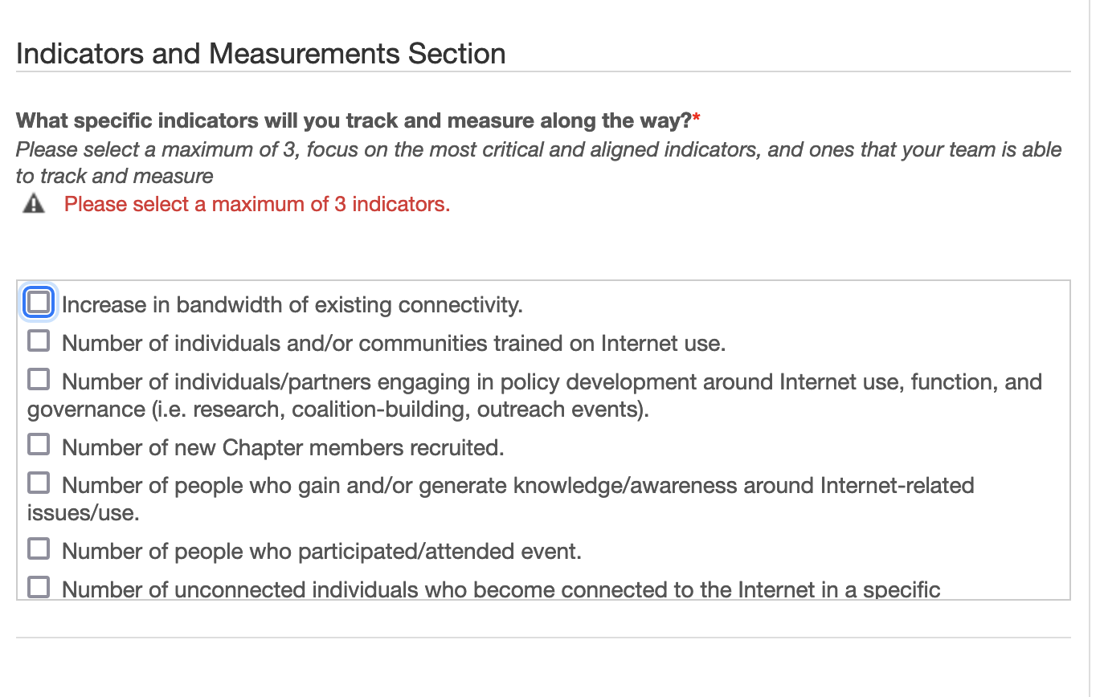

The “Indicators and Measurements” section from a Beyond the Net application in Fluxx